|  |  |
| --- | --- |
| **CSE 420**  **Section 01**  **Surprise Quiz 01**  **16th May, 2016**  **Total Time: 10 minutes** | **SET B** |

**Student Name:**

**Student ID:**

1. Define Token. [2]
   * + A pair consisting of a token name and an optional attribute value.
     + A particular keyword, or a sequence of input characters denoting identifier.

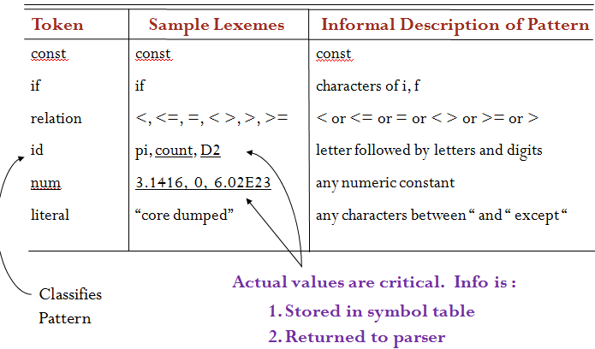

1. Convert the following NFA to DFA using subset construction method.[8]

